Packard Industries Manufacturers of Rebuilders Choice Products
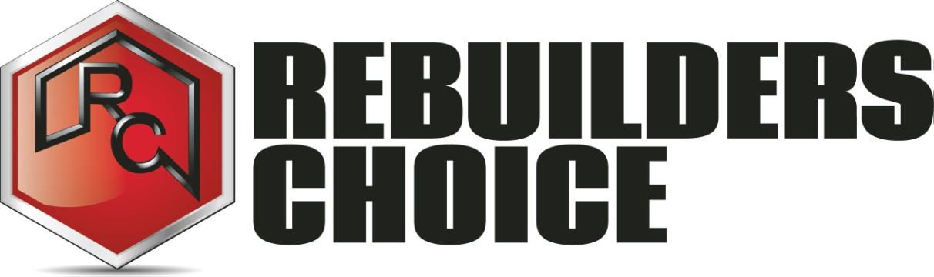
662 Myrtle Ave Boonton NJ 07005
Phone: 1-800-768-3646 Fax: 973-334-5387

Customer Account Application (Part 2)

Company Name:

Contact information

Company Website:

Company Email:

Authorized Purchasers

Name:

Email:

Phone:

Name:

Email:

Phone:

Accounts Receivable

Name:

Phone:

Email:

Fax:

Signed: Date:

Name Printed:

